

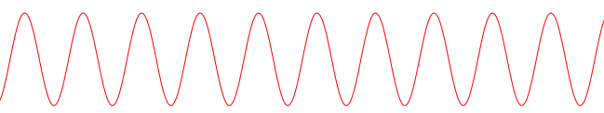

t

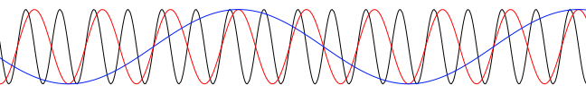

t

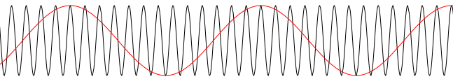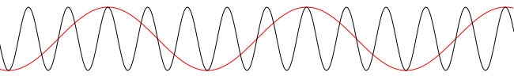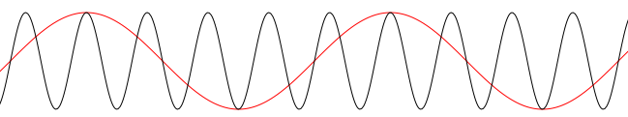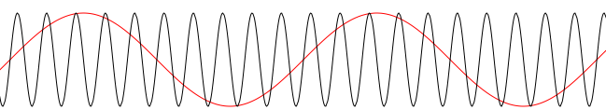

*constant*



*constant*



t

t



t

t